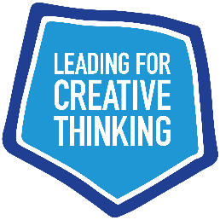**Tell us your story…**

We are on a mission to gather inspiring insights and experiences of [Leading for Creative Thinking](https://leadingforcreativethinking.org/) to share on the ‘stories’ area of our website.

This is a space to celebrate experiences of creative leadership and showcase individual leadership development. The aim is for your learnings to inspire the growing community of those at every stage of the Leading for Creative Thinking journey. See examples of Stories from other creative educational leaders on the [Stories page](https://leadingforcreativethinking.org/stories).

When writing your story we invite you to think about this from a 'we' rather than 'I' perspective and you may want to consider the following questions to help you get started:

● What is the context for what we have been/ are trying to do and any opportunities or constraints for promoting creative thinking in school? (There may be readers from other countries).

● Why did we decide to introduce creative thinking?

● What did we do?

● What successes have we had (so far)?

● What leadership challenges have we faces/ are we facing?

● How have we overcome these or how are we thinking about overcoming them?

● What have we learnt so far about leading for creative thinking?

● What key messages do we want to get across about leading for creative thinking?

**Leading for Creative Thinking: Your Story**

Please use the following headings and format to write your story as a short form blog (up to 1000 words - about a 3-5 minute read), using this word document template and send to [andrea.mercer@cceengland.org](mailto:andrea.mercer@cceengland.org)

**Photo/s which illustrate your story**: [Please send good quality images via [WeTransfer](https://wetransfer.com/) to [andrea.mercer@cceengland.org](mailto:andrea.mercer@cceengland.org) you must have parental consent and permission for worldwide use is needed for any people who are visible and who will not be named.]

**Name/s of Author/s:**

**Name of School:**

**Your Role:**

**Story Title:**

**Story Subtitle and/ or Introductory Summary**:

**Your Story:** [up to 1000 words and could also include links, diagrams, tables etc.]

**Reflection Questions:** [Please share any reflection questions which you might want people to think about and use for learning conversations about your story]